DEVELOP A WEB APPLICATION USING NODE-RE

|  |  |
| --- | --- |
| Date | 09 November 2022 |
| Team ID | PNT2022TMID42038 |
| Project Name | Project – IOT Based Real – time River Water Quality Monitoring and Control  System |
| Maximum Marks | 4 Marks |

1. Double-click the tab with the flow name, and call it Earthquake Details.
2. Click the hamburger menu, and then click **Manage palette**. Look for **node-red-node- open weather map** to install these additional nodes in your palette.

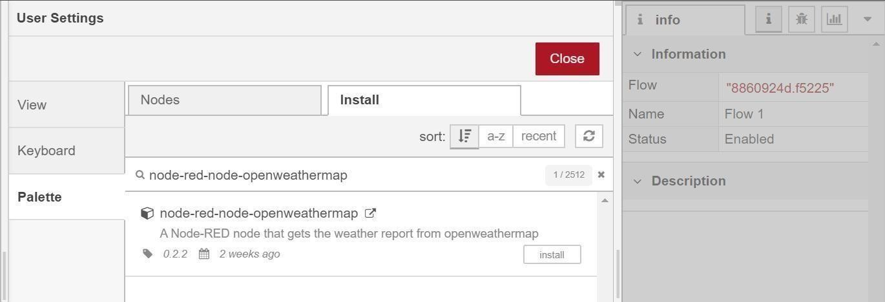

Add an **HTTP input** node to your flow.

Double-click the node to edit it. Set the method to GET and set the URL to /earthquakeinfo-hr.

* 1. Add an **HTTP response** node, and connect it to the previously added **HTTP input** node.All other nodes introduced in this sub-section is to be added between the **HTTP input** node and the **HTTP response** node.
  2. Add an **HTTP request** node and setthe *URL* to

https://earthquake.usgs.gov/earthquakes/feed/v1.0/summary

/all_hour.geojson, the *Method* to **GET** and the *Return* to **a parsed JSON object**. This will allow extracting all earthquakes that occurred within the last hour. Name this node Get

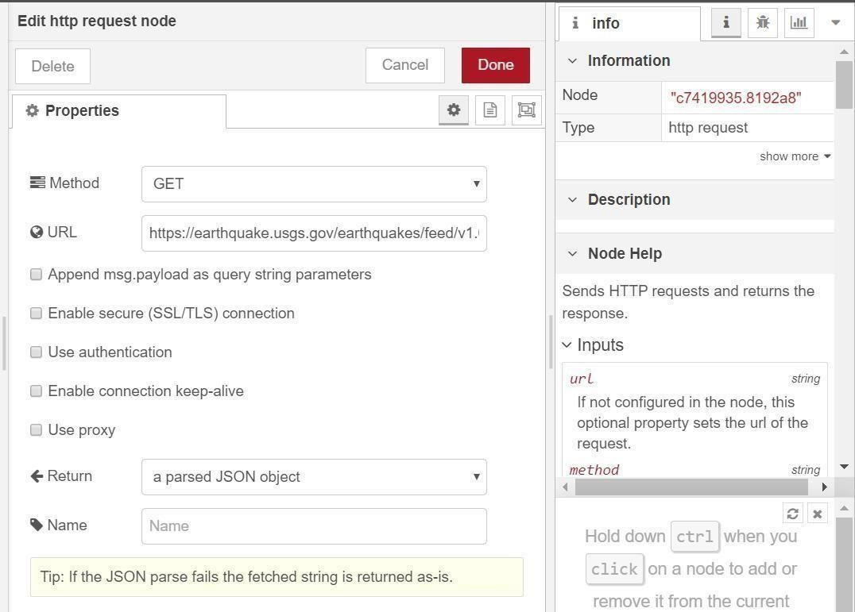

Add a **change** node. Double-click the node to modify it. Name this node Set Earthquake Info. In

the **Rules** section, addes

rul to *Delete* msg.topic,

msg.headers, msg.statusCode, msg.responseUrland

msg.redirectLis

t and

*Set*d payload.features.

msg.payloa

{

"type":properties.type, "magnitude": properties.mag, "location": properties.place, "longitude":geometry.coordinates[0], "latitude":geometry.coordinates[1], "depth":geometry.coordinates[2],

"timestamp": $fromMillis(properties.time,